**LAB 5 Report**

**Đoàn Nam Sơn**

**De180896**

App.js

Home.js:  
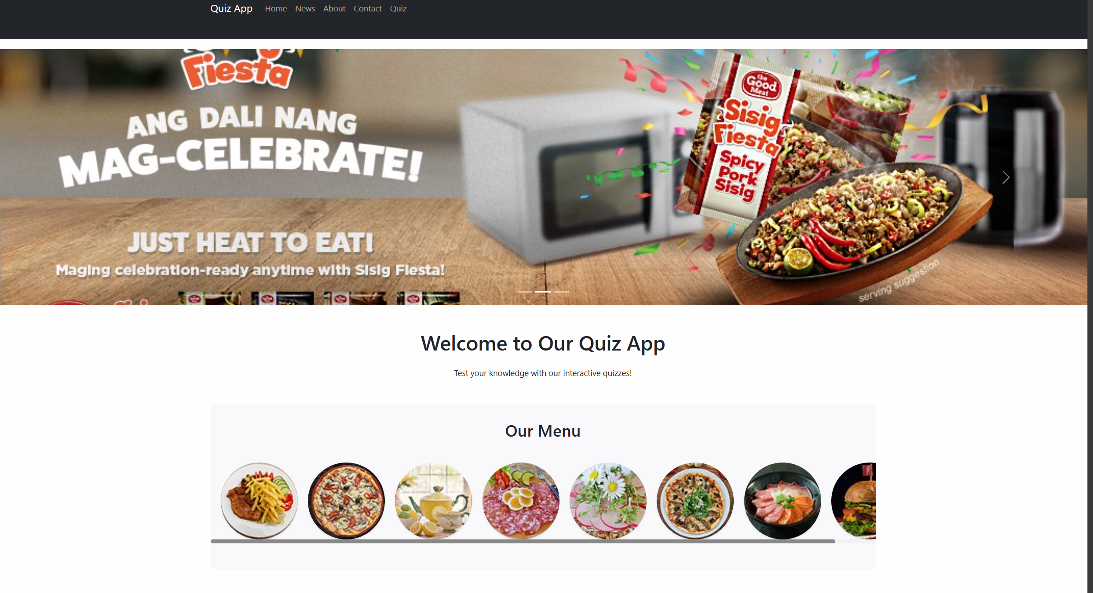

News.js

About.js

Contact.js

Quiz.js

